**Database Management System – cs422 DE**

**Lab 4 – Week 9**

-----------------------------------------------------------------------------------------------------------------

**This Lab is based on Conceptual and Logical DB design.**

* Submit your *own work* on time. No credit will be given if the lab is submitted after the due date.
* Note that the completed lab should be submitted in .doc, .docx, .rtf, .pdf or .zip format only.   
  ---------------------------------------------------------------------------------------------------------------

**The *EasyDrive School of Motoring* case study**

Solve exercise 17.11/16.11 from the 5th /4th edition of the course text book.   
  
EasyDrive School of Motoring case study is documented in Appendix B.2. Read it properly.

To get full credit for this lab, you need to complete the following 2 tasks.

(1) Create a conceptual data model for the above case study. State any assumptions necessary to

support your design.

ANS:

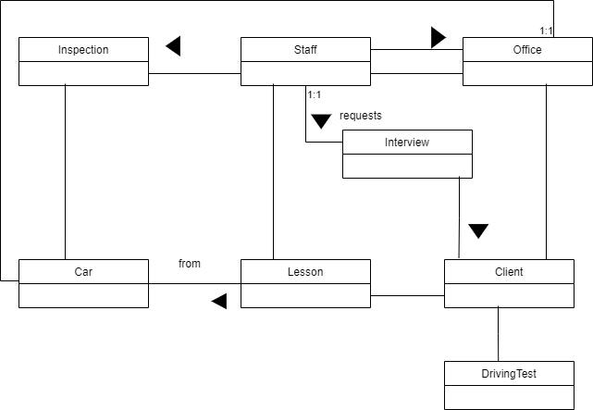

(2) Create and validate a logical data model from the conceptual data model created in (1) above.

ANS:

